**Azure DevOps Demo Generator**

The **Azure DevOps Demo Generator** (often just called DevOps Generator) is a free, Microsoft-provided online tool that helps users quickly create sample Azure DevOps projects populated with pre-configured content — like work items, pipelines, repos, boards, and dashboards.

**Official site:** https://azuredevopsdemogenerator.azurewebsites.net/

It connects to your Azure DevOps organization and generates fully working demo projects based on templates you select.

If you're learning Azure DevOps, it can be time-consuming to manually create projects, pipelines, boards, and repos from scratch. The generator instantly sets up real, ready-to-use projects so you can focus on understanding and using the tools rather than building everything from the ground up.

We can download and import ready-made demo projects (whether in Java, Python, or .NET) from the Azure DevOps Demo Generator. This helps us easily understand what a real-world project looks like, and clearly see how the boards, stages, and pipeline flows are structured by exploring these demo projects.

Let’s Import a Demo project from the Azure DevOps Demo generator:

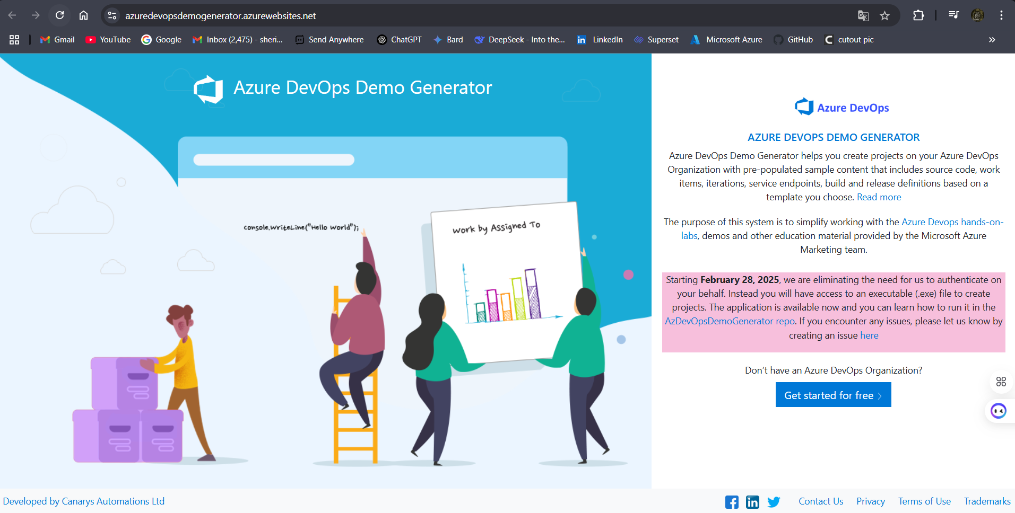

Fig: First web page interface.